**Multi-Tasking vs Multi-Threading**

* By the name, people think these both are the same thing or one is a subset of others and they get confused between these and not able to distinguish between these terms. Although, multi-tasking is simply the execution of multiple tasks and multi-threading is thread-based multitasking. In computer, multitasking is the concurrent execution of multiple tasks and multithreading is the ability of a processor to provide multiple threads which execute concurrently.

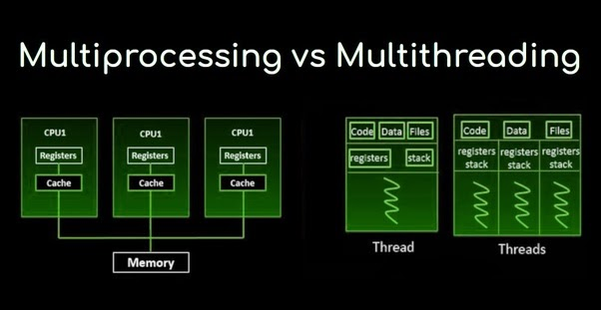

* On the basis of **switching**, in multitasking, the switching between the programs is frequently on the other hand in multithreading the switching between the thread is frequently.

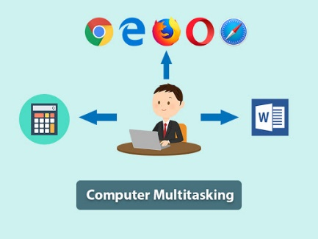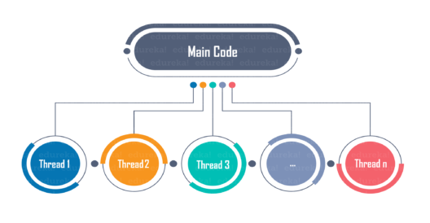

* On the basis of **memory** and resource, the multitasking allocates the separate memory to execute each program while multithreading shares the same memory and resources to run concurrent threads.

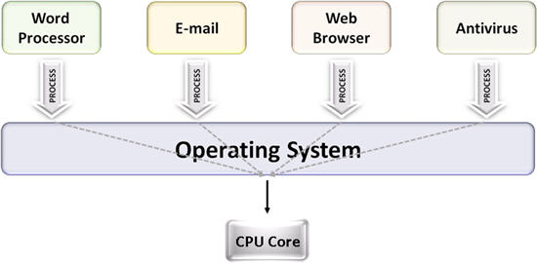 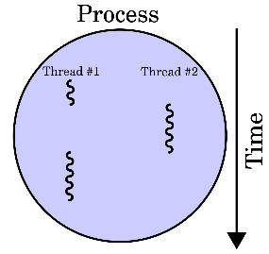

* On the basis of the **cost,** it’s difficult to create different process and it’s costlier while creating threads is easier because they don’t take separate memory allocation as well as sperate resources.
* Multithreading is more responsive than multitasking because the user would not have to wait if the one thread is not responding the other thread would response and give the result they are not dependent with each other.